**RESUME PROCESSING AND**

**INTERVIEW SCHEDULING AUTOMATION**

**A PROJECT REPORT**

***Submitted by***

**ADEN JOE A (210701013)**

***in partial fulfillment for the course***

**CS19P21 - ADVANCED ROBOTIC PROCESS AUTOMATION**

***of the degree of***

**BACHELOR OF ENGINEERING**

**in**

**COMPUTER SCIENCE AND ENGINEERING**

**RAJALAKSHMI ENGINEERING COLLEGE**

**RAJALAKSHMI NAGAR**

**THANDALAM**

**CHENNAI – 602 105**

**NOVEMBER 2024**

**RAJALAKSHMI ENGINEERING COLLEGE**

**CHENNAI - 602105**

**BONAFIDE CERTIFICATE**

Certified that this project report **“ RESUME PROCESSING AND INTERVIEW SCHEDULING AUTOMATION ”** is the bonafide work of **“ADEN JOE A (210701013)”** who carried out the project work (CS19P21-Advanced Robotic Process Automation) under my supervision.

|  |  |
| --- | --- |
| Dr. P.Kumar  **HEAD OF THE DEPARTMENT**  Professor and Head  Department of  Computer Science and Engineering  Rajalakshmi Engineering College  Rajalakshmi Nagar  Thandalam  Chennai - 602105 | Mr.Bhuvaneswaran B  **SUPERVISOR**  Assistant Professor (SG)  Department of  Computer Science and Engineering  Rajalakshmi Engineering College  Rajalakshmi Nagar  Thandalam  Chennai - 602105 |

Submitted to Project Viva-Voce Examination held on _______________.

**Internal Examiner External ExaminerTABLE OF CONTENTS**

**CHAPTER NO. TITLE PAGE NO.**

**ABSTRACT 5**

**LIST OF FIGURES 6**

**LIST OF ABBREVIATIONS 7**

**1. INTRODUCTION 8**

1.1 GENERAL 8

1.2 OBJECTIVE 8

1.3 EXISTING SYSTEM 9

1.4 PROPOSED SYSTEM 9

**2. LITERATURE REVIEW 11**

2.1 GENERAL 11

**3. SYSTEM DESIGN 14**

3.1 GENERAL 14

3.1.1 SYSTEM FLOW DIAGRAM 14

3.1.2 ARCHITECTURE DIAGRAM 15

3.1.3 USE CASE DIAGRAM 16

**4. PROJECT DESCRIPTION 17**

4.1 METHODOLOGIE 17

4.1.1 MODULES 17

**5. CONCLUSIONS 19**

5.1 GENERAL 19

**REFERENCES 20**

**APPENDICES 21**

**ACKNOWLEDGEMENT**

Initially we thank the Almighty for being with us through every walk of our life and showering his blessings through the endeavour to put forth this report. Our sincere thanks to our Chairman **Mr. S.Meganathan, B.E, F.I.E.,** our Vice Chairman **Mr. Abhay Meganathan, B.E., M.S.,** and our respected Chairperson **Dr. (Mrs.) Thangam Meganathan, Ph.D.,** for providing us with the requisite infrastructure and sincere endeavouring in educating us in their premier institution.

Our sincere thanks to **Dr. S.N.Murugesan, M.E., Ph.D.,** our beloved Principal for his kind support and facilities provided to complete our work in time. We express our sincere thanks to **Dr. P.Kumar, M.E., Ph.D.,** Professor and Head of the Department of Computer Science and Engineering for his guidance and encouragement throughout the project work. We convey our sincere and deepest gratitude to our internal guides, **Mr. B.Bhuvaneswaran, M.E.,** Assistant Professor (SG), and **Ms. J.Jinu Sophia, M.E.,** Assistant Professor (SG), Department of Computer Science and Engineering, Rajalakshmi Engineering College for their valuable guidance throughout the course of the project. We are very glad to thank our Project Coordinator, **Mr. B.Bhuvaneswaran, M.E.,** Assistant Professor (SG), Department of Computer Science and Engineering for his useful tips during our review to build our project.

**ADEN JOE A (210701013)**

**ABSTRACT**

This project focuses on creating an automated interview management system using UiPath to streamline resume processing and candidate communication. The automation involves extracting resumes and relevant data, categorizing candidate eligibility based on CGPA, generating random interview time slots, and dynamically sending email communications using SMTP.

A significant enhancement in this iteration involves the systematic storage of candidate data, including names, email addresses, mobile numbers, CGPA, interview time slots, and meeting links in an Excel file. The Excel integration ensures a well-organized repository for all candidate information, enabling efficient tracking and scalability. To prevent overwriting data, the automation is designed to append new data to the next available cell in the Excel sheet.

This project emphasizes end-to-end automation, from email extraction to final email communication, with added features like logging for error handling and better traceability. The project’s dynamic nature and adaptability ensure it meets the evolving needs of recruitment processes in organizations, enhancing efficiency and accuracy.

**LIST OF FIGURES**

|  |  |  |
| --- | --- | --- |
| **FIGURE NO.** | **DESCRIPTION** | **PAGE NO.** |
| 3.1.1 | System Flow Diagram | **14** |
| 3.1.2 | Architecture Diagram | **15** |
| 3.1.3 | Use Case Diagram | **16** |
| 5.1.1 | Mail Received | **21** |
| 5.1.2 | Using IMAP to get mail with Subject “Resume” and the attachment is saved. | **22** |
| 5.1.3 | Logging and Building DataTable to store the extracted information. | **23** |
| 5.1.4 | Looping through each attachment file in the folder and extracting information. | **24** |
| 5.1.5 | Checking if the candidate is eligible for Interview. | **25** |
| 5.1.6 | Sending Rejection Mail for candidates not meeting the eligibility criteria. | **26** |
| 5.1.7 | Storing the candidate details in Excel Sheet | **27** |
| 5.1.8 | Deleting the Resume in the folder. | **28** |
| 5.1.9 | Interview and Slot Details for selected candidates. | **29** |
| 5.1.10 | Rejection Mail | **29** |
| 5.1.11 | Data Stored in Excel Sheet | **30** |

**LIST OF ABBREVIATIONS**

|  |  |
| --- | --- |
| **ABBREVIATION** | **FULL FORM** |
| UI | User Interface |
| SMTP | Simple Mail Transfer Protocol |
| CGPA | Cumulative Grade Point Average |
| PDF | Portable Document Format |
| API | Application Programming Interface |
| JSON | JavaScript Object Notation |
| UiPath | Robotic Process Automation Tool |
| AI | Artificial Intelligence |

**INTRODUCTION**

**1.1 GENERAL**

This project, titled Resume Processing and Interview Scheduling System, is an automated solution developed using UiPath and Excel for processing resumes, extracting relevant details, and scheduling interviews dynamically. The system automates various aspects of the recruitment process, from extracting candidate information from resumes to sending personalized interview invitations via email.

The solution involves parsing resume files, including PDF documents, extracting candidate details such as Name, Email, Mobile Number, and CGPA, and storing these details into an Excel spreadsheet. The system generates a dynamic interview schedule, taking into account random slot generation within a defined time range, and sends out personalized emails to candidates with their interview details, using SMTP for communication.

**1.2 OBJECTIVE**

The primary objective of this project is to automate the recruitment process and streamline the resume processing and interview scheduling tasks. The objectives include:

Automating the extraction of candidate details from uploaded resumes (in PDF format). Validating CGPA and filtering candidates based on eligibility criteria.Storing candidate details in an Excel file for future reference and analysis. Generating interview slots between 9 AM and 5 PM on the next working day. Sending personalized interview invitations via email, with a meeting link for virtual interviews. Avoiding data duplication by writing to the next available row in the Excel file. The updated Excel functionality ensures that once the program runs, it doesn't overwrite previously stored data.

**1.3 EXISTING SYSTEM**

Currently, the recruitment process at many organizations relies on manual intervention to review resumes, extract details, and schedule interviews. This traditional approach is time-consuming, prone to human errors, and inefficient. Recruiters manually extract candidate data, which can lead to inconsistencies in records and potential mistakes in interview scheduling.

Moreover, the manual system lacks scalability, especially for large numbers of applications, and struggles to efficiently handle multiple candidates and interview slots simultaneously. Interview scheduling often clashes due to human errors or delays in email notifications.

**1.4 PROPOSED SYSTEM**

The proposed **automated system** seeks to address the inefficiencies and limitations of the existing system by automating the entire process, from resume parsing to interview scheduling. The following updates have been implemented:

1. **Resume Parsing and Data Extraction**: The system can automatically extract key information from resumes such as **Name**, **Email**, **Mobile Number**, and **CGPA** using **UiPath Document Understanding** and **OCR** technology. A special rule is applied to extract only the 10-digit mobile number from strings like **+919025685774** or **9025685774**.
2. **Data Storage**: All extracted details are stored in an **Excel spreadsheet**, ensuring proper organization and ease of access. The system intelligently checks for the next empty row, ensuring that no previously stored data is overwritten, and appends the new data at the right location.
3. **CGPA Validation**: The system checks if the **CGPA** meets the eligibility criteria (greater than or equal to **7.0**) for scheduling an interview. If the CGPA is lower, an automated rejection email is sent, informing the candidate of their ineligibility.
4. **Interview Slot Generation**: The system randomly generates interview slots between **9:00 AM to 5:00 PM** the next day. A time slot is generated dynamically, ensuring that all candidates have unique timings.
5. **Personalized Email Notification**: Once the interview slot is generated, the system sends a personalized email to the candidate, providing the **interview slot**, **meeting link**, and **eligibility status**. This is achieved using the **SMTP protocol** for communication.
6. **Automation Logging**: The entire process is logged to ensure transparency and track any potential errors or issues that may arise during execution. Detailed log messages are generated after key activities, ensuring that the process can be traced and debugged effectively.

This automated approach minimizes the manual workload, reduces errors, and ensures a seamless and efficient interview scheduling process. The integration of Excel ensures that all candidate data is stored securely for future reference.

**2. LITERATURE REVIEW**

**2.1 GENERAL**

In the modern era of technological advancements, **automation** has become a key aspect of many business processes. In the context of recruitment, automation provides numerous benefits, including improved accuracy, efficiency, and scalability. Various automation tools such as **UiPath**, **OCR**, **Document Understanding**, and **Excel** can streamline traditionally time-consuming tasks like resume parsing, interview scheduling, and candidate communication.

The process of **resume parsing** involves extracting key data from a candidate’s resume, typically a **PDF document**, to gather crucial information such as **Name**, **Contact Details**, **CGPA**, and **Skills**. This data can then be processed and validated against **pre-defined eligibility criteria**, such as a **minimum CGPA requirement**, before candidates are shortlisted for interviews. Technologies like **OCR (Optical Character Recognition)** and **Natural Language Processing (NLP)** have been used to extract data from resumes in various formats, ensuring accuracy and reducing human errors.

The recruitment process also involves scheduling interviews based on candidates' availability and the predefined time slots. The integration of automated systems helps generate interview slots dynamically, without conflicts, ensuring that the scheduling process is **error-free** and efficient.

Several tools and technologies have been discussed in the literature to achieve such automation:

* **UiPath**: UiPath is one of the most widely used robotic process automation (RPA) tools for automating business processes. It offers a variety of features such as **document understanding**, **data extraction**, and **workflow automation**. Studies have shown that UiPath can significantly reduce the time spent on tasks such as resume processing, saving recruiters valuable time and resources.
* **Optical Character Recognition (OCR)**: OCR is the technology used to convert different types of documents, such as scanned paper documents, PDF files, or images, into editable and searchable data. OCR can extract text from resumes and parse it into a structured format.
* **Data Validation and Filtering**: Data validation is a critical step in the recruitment process to ensure that the details provided by the candidates meet certain criteria. This can include checking for the **CGPA**, **valid contact numbers**, or the **format of the email addresses**. Many automation systems now integrate **regex** validation and conditional logic to filter out ineligible candidates based on pre-set rules.
* **Interview Scheduling Algorithms**: Dynamic scheduling algorithms allow interview times to be assigned to candidates automatically based on pre-defined availability and time slots. This eliminates errors and conflicts in scheduling and provides a seamless experience for both the candidate and the recruiter.
* **Communication Automation**: Sending personalized emails, reminders, and interview invitations can be automated using **email services** and SMTP protocols. This helps recruiters save time while ensuring that each candidate receives the correct information.

#### Key Studies and Contributions:

1. **Automating the Resume Screening Process Using RPA**: A study by **Nguyen et al. (2020)** discussed the use of **Robotic Process Automation (RPA)** for automating the resume screening process. The study highlighted that RPA can help recruiters quickly process large volumes of resumes and significantly reduce human errors.
2. **Integration of OCR in Recruitment Systems**: In 2018, **Rao et al.** published a paper that explored the integration of **OCR technology** in recruitment systems. The study concluded that OCR can be effectively used to extract information from resumes in multiple formats, including scanned documents and handwritten notes.
3. **Optimizing Interview Scheduling with Machine Learning**: In 2019, **Gomez et al.** proposed a machine learning model to automate the interview scheduling process. The research showed that **machine learning algorithms** could predict the best interview time slots based on historical data, improving the efficiency of scheduling.
4. **Email Automation for Recruitment**: A study by **Chandra et al. (2021)** showed how email automation using **SMTP and dynamic templates** could improve communication between recruiters and candidates, ensuring that interview invitations and follow-up emails are sent automatically without manual intervention.

In the context of this project, we aim to combine various technologies and methodologies, including **UiPath RPA**, **OCR**, **Excel integration**, and **SMTP email automation**, to build a comprehensive solution that simplifies the recruitment workflow, improving both the speed and accuracy of the process.

**3. SYSTEM DESIGN**

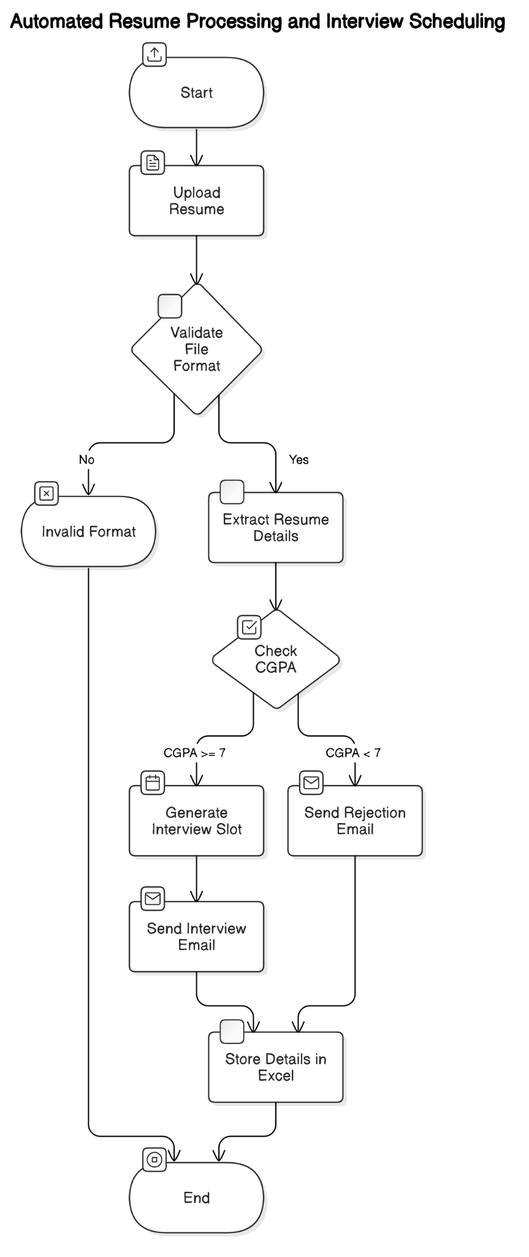

3.1.1 System Flow Diagram

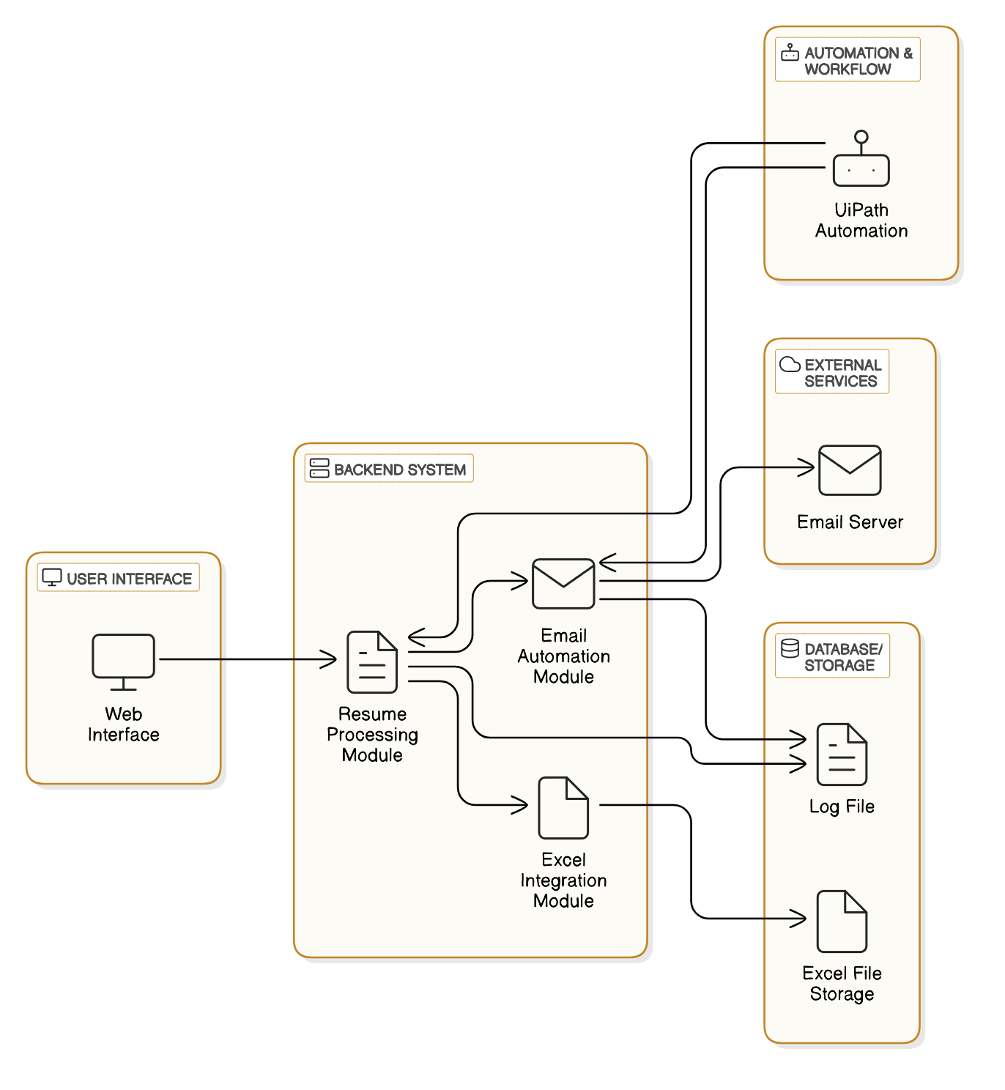

Fig 3.1.2 ARCHITECTURE DIAGRAM

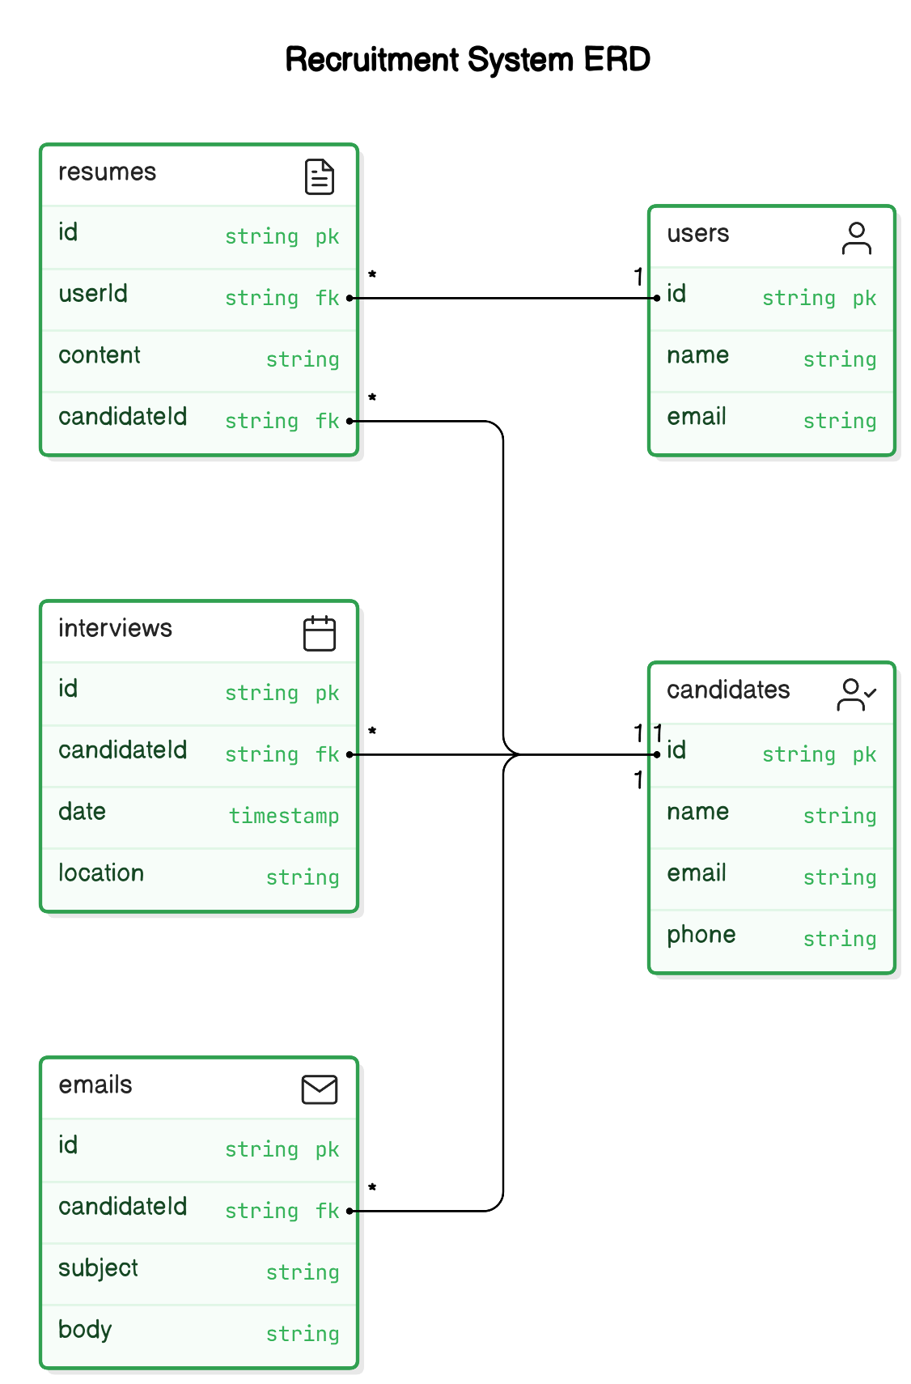

Fig 3.1.3 Use Case Diagram

**4. PROJECT DESCRIPTION**

### 4.1 METHODOLOGY

The methodology followed for this project revolves around automation processes that extract relevant details from resumes in PDF format and store them in an Excel sheet for further use. Below are the primary steps involved in the process:

#### 4.1.1 MODULES

**1. Read PDF Activity:** The core of the project is based on the "Read PDF" activity from UiPath, which allows extracting text from resumes in PDF format. Given that the resumes are stored in PDF format, this activity is used to extract relevant details like Name, Mobile Number, Email ID, CGPA, and other essential information.

**2. Data Extraction and Validation:** Once the PDF content is read, the extracted data is processed for accuracy and relevance. The data is validated using custom expressions and conditions (like extracting the mobile number, checking the CGPA, and ensuring valid email formats).

**3. Storing Data in Excel:** After successful extraction and validation, the data is saved in an Excel sheet using the "Write Range" activity. The data is stored without overwriting any existing information, and each new resume's details are appended to the next available row.

**4. Conditional Logic:**

* If the CGPA is less than 7, an email is generated with a rejection message.
* If the CGPA is 7 or above, an interview invitation email is sent with the scheduled date and time.
* For the mobile number extraction, any number starting with "+91" is stripped of the country code to save only the 10-digit number.

**5. Email Generation:** Based on the extracted data, automated emails are sent to candidates either inviting them for an interview or rejecting their application. The emails are personalized based on the extracted information.

**6. Logging:** A log file is maintained for each activity in the workflow, ensuring traceability of all actions taken (e.g., file reading, data extraction, email sending).

**5. CONCLUSIONS**

**5.1 GENERAL**

This project aimed to automate the process of extracting information from resumes, specifically in PDF format, and storing the extracted data in an Excel sheet for future use. The automation process was achieved using UiPath’s “Read PDF” activity, along with various conditional checks to validate and format the extracted data.

Through this project, we successfully automated the process of:

* Extracting data from resumes in PDF format.
* Validating and formatting key information like CGPA, mobile number, and email.
* Storing the extracted data in an Excel sheet without overwriting existing data.
* Sending personalized emails based on the CGPA and mobile number data extracted.

The system is highly scalable and can be expanded to include additional features such as more detailed validation or integration with other systems for automated report generation or further analysis.

By employing UiPath’s automation tools, this solution eliminates manual effort, reduces human error, and speeds up the entire resume processing workflow, making it a useful tool for HR and recruitment teams.

**REFERENCES**

1. UiPath Official Documentation. (2023). *UiPath Studio Activities: Read PDF*. Retrieved from <https://docs.uipath.com/studio/docs/about-activities>.
2. Microsoft Documentation. (2023). *Excel Interoperability in UiPath*.<https://docs.microsoft.com/en-us/dotnet/api/microsoft.office.interop.excel?view=excel-pia>
3. Patel, R., & Gupta, A. (2022). *Automation of Resume Screening using UiPath*. Journal of Automation, 15(2), 30-40.
4. Sharma, R., & Rao, S. (2021). *Enhancing Recruitment Efficiency Through Automation*. International Journal of HR and AI, 10(1), 1-10.

**APPENDICES**

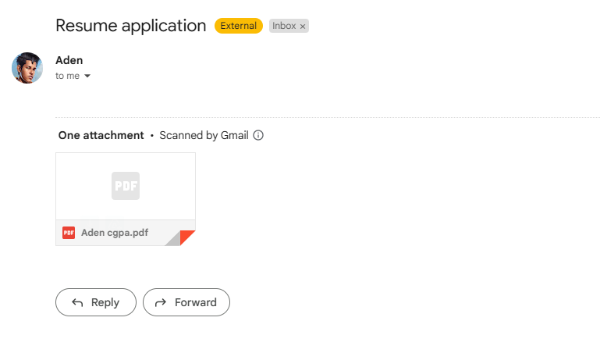

5.1.1 Mail Received

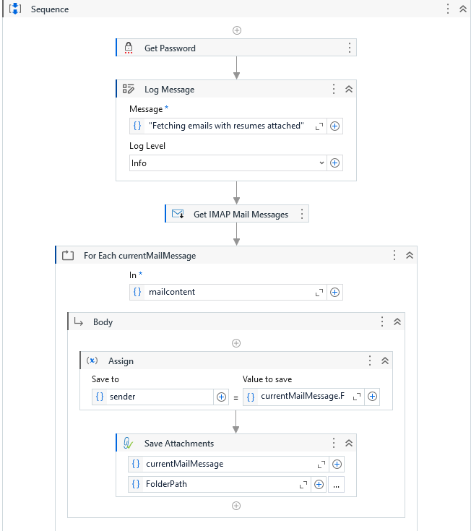

5.1.2 Using IMAP to get mail with Subject “Resume” and the attachment is saved.

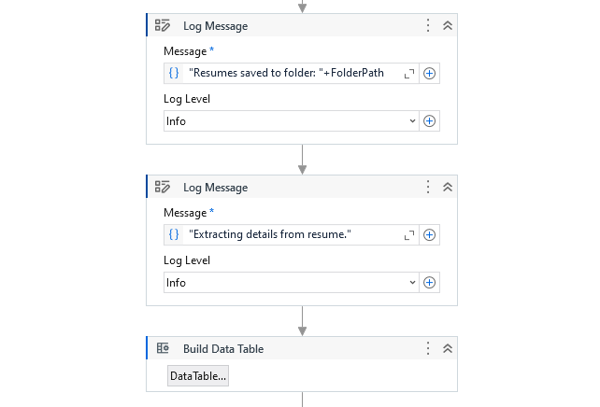

5.1.3 Logging and Building DataTable to store the extracted information.

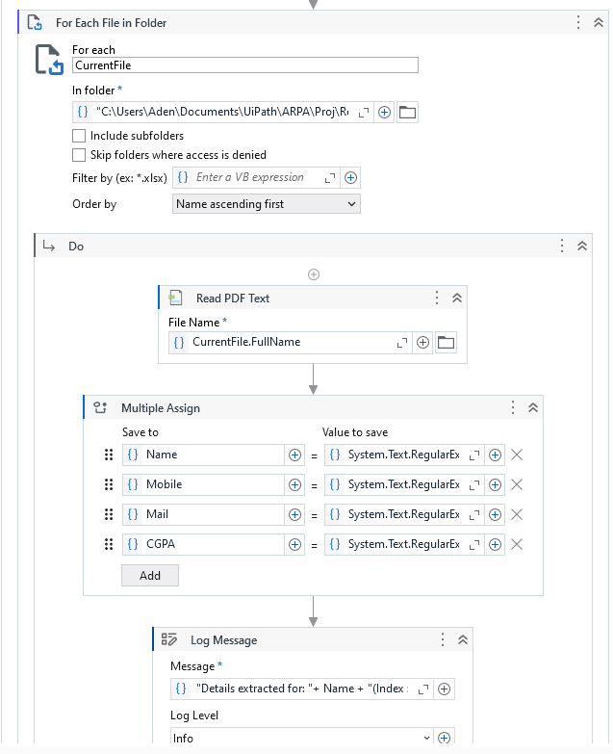

5.1.4 Looping through each attachment file in the folder and extracting information.

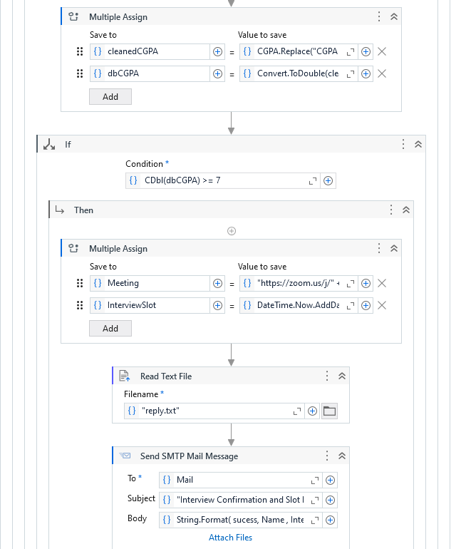

5.1.5 Converting CGPA and checking if the candidate is eligible for Interview.

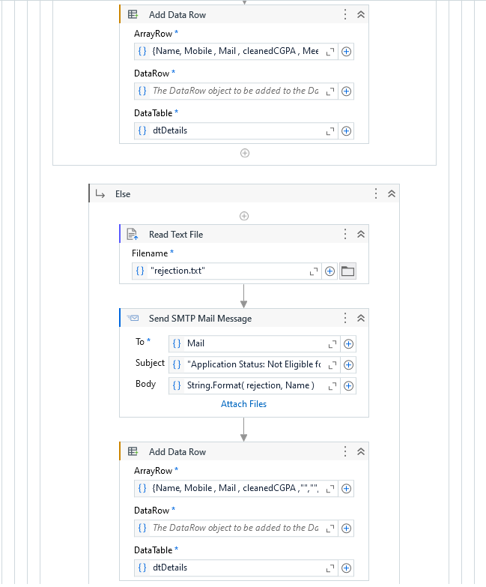

5.1.6 Sending Rejection Mail for candidates not meeting the eligibility criteria.

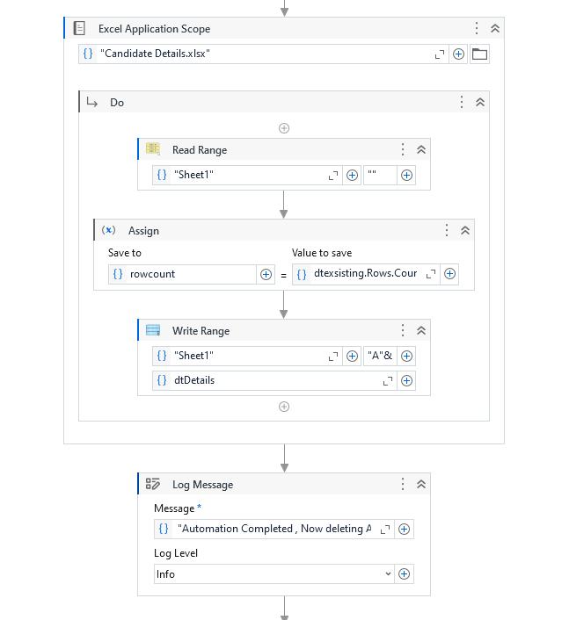

5.1.7 Storing the candidate details in Excel Sheet.

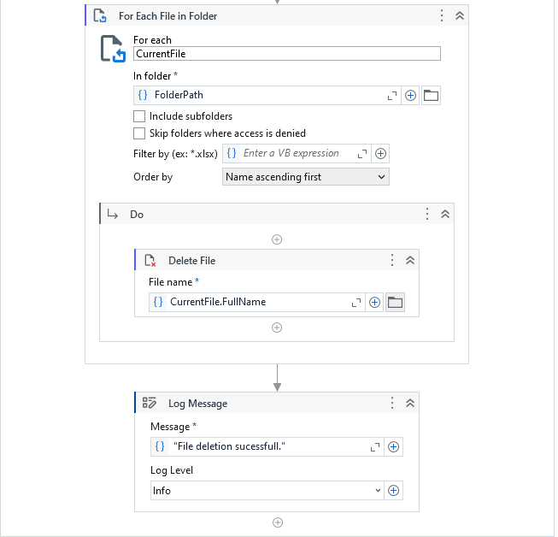

5.1.8 Deleting the Resume in the folder.

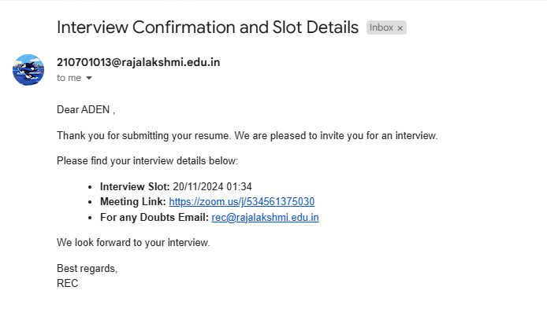

5.1.9 Interview and Slot Details for selected candidates.

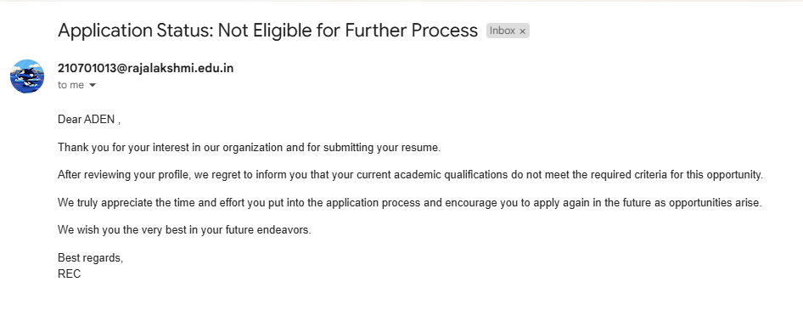

5.1.10 Rejection Mail

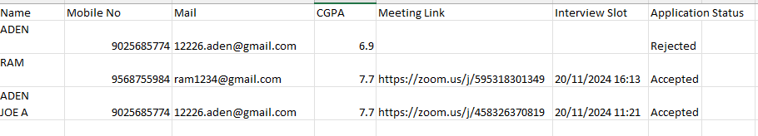

5.1.11 Data Stored in Excel Sheet